**ASSIGNMENT 3  
 REPORT**

**CHANDRA SEKHAR YELLAPU**

Output Screen displaying the Teddy in **OPENGL** window

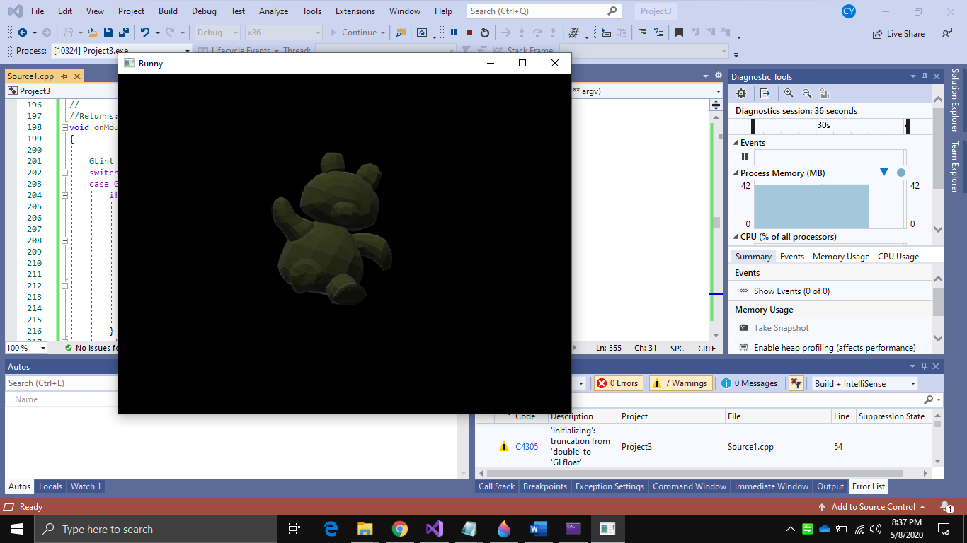

Rotating the Teddy

